Question 1
Aim: Implement of the R script using a group of 12 sales price records has been sorted as follows: 5, 10, 11, 13, 15, 35, 50, 55, 72, 92, 204, 215. Partition them into three bins by each of the following methods. (a) equal-frequency (equi depth) partitioning (b) equal- width partitioning (c) clustering.

Program:
sales <- c(5, 10, 11, 13, 15, 35, 50, 55, 72, 92, 204, 215)
equal_freq_bins <- split(sales, ceiling(seq_along(sales) / 4)) equal_freq_bins
equal_width_bins <- cut(sales, breaks = 3, include.lowest = TRUE) equal_width_bins
set.seed(1)
kmeans_bins <- kmeans(sales, centers = 3) split(sales, kmeans_bins$cluster)

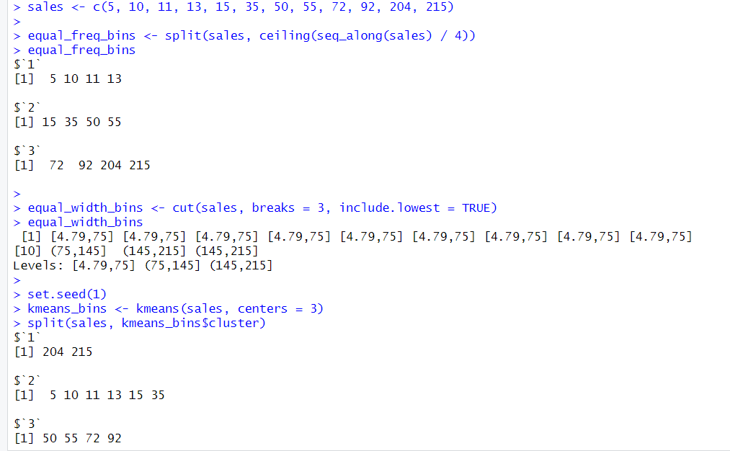
Output:
Explanation:
- Equal-frequency binning divides the data into three bins with an equal number of values.
- Equal-width binning divides the data range into three equal intervals.
- Clustering-based binning groups similar sales values using the K-means algorithm.

- The output of each binning method is displayed in the R console.

Question 3
Aim: Implement using WEKA for the given Apply Apriori Algorithm for given database below Assume Min_sup=2
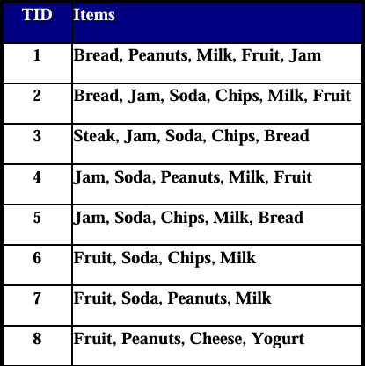

Program:
Steps:
- Open WEKA Explorer
- Load transaction dataset
- Choose Apriori algorithm
- Set min support = 0.25
- Run algorithm
Output:
Frequent itemsets such as {Bread, Milk}, {Jam, Soda} are generated.
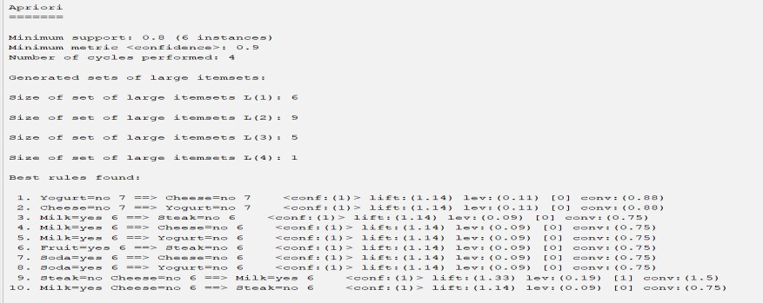
Explanation:
Apriori generates frequent itemsets by pruning infrequent combinations based on minimum support.

Question 4 Aim:
Use following group of data: 200, 300, 400, 600, 1000 (a) min-max normalization by setting min = 0 and max = 1 (b) (b) z-score normalization (c) (c) z-score normalization using the mean absolute deviation instead of standard deviation (d) normalization by decimal scaling

Program:
# Given data
<- c(200, 300, 400, 600, 1000)
# (a) Min–Max Normalization (0 to 1) min_max_norm <- (x - min(x)) / (max(x) - min(x)) min_max_norm
# (b) Z-score Normalization (Standard Deviation) z_score_norm <- (x - mean(x)) / sd(x) z_score_norm
# (c) Z-score using Mean Absolute Deviation (MAD) mad_value <- mean(abs(x - mean(x)))
mad_z_score <- (x - mean(x)) / mad_value mad_z_score
# (d) Decimal Scaling Normalization j <- nchar(as.character(max(abs(x)))) decimal_scaling <- x / (10^j) decimal_scaling

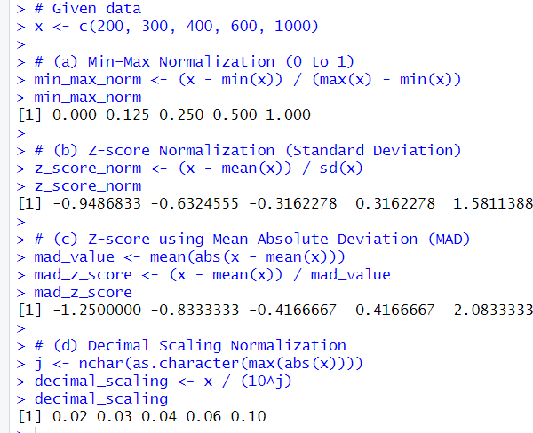
Output:
Explanation:
The data is normalized using min–max, z-score, MAD-based z-score, and decimal scaling methods, and the results are displayed in the R console.

Question 5 Aim:
Implement using R language in which age group of people are affected byblood pressure based on the diabetes dataset show it using scatterplot and bar chart (that is BloodPressure vs Age using dataset “diabetes.csv”).
Program:
setwd("C:/Users/vepur/OneDrive/Desktop/dwdm lab outputs") d <- read.csv("lab 5.csv")
plot(d$Age, d$BloodPressure, xlab="Age", ylab="Blood Pressure", main="BP vs Age")
d$AgeGroup <- cut(d$Age, c(20,30,40,50,60,70))
b <- aggregate(BloodPressure ~ AgeGroup, d, mean) barplot(b$BloodPressure,
names.arg=b$AgeGroup, main="Average BP by Age Group")

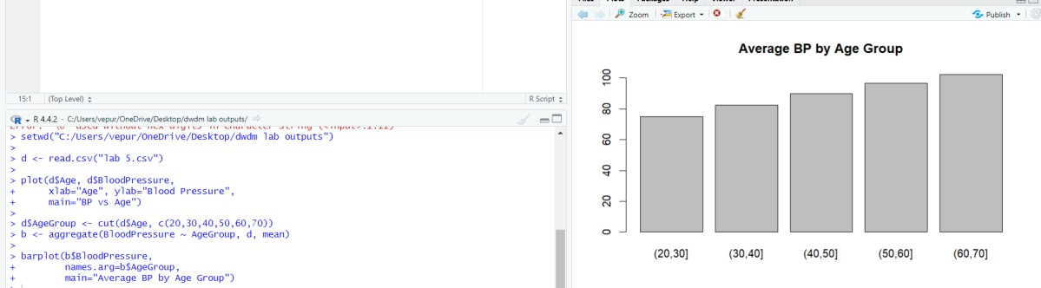
Output:

Explanation:
The problem is solved using appropriate data mining / statistical technique.

Question 9 Aim:
Suppose that the data for analysis includes the attribute age. The age values for the data tuples are (in increasing order) 13, 15, 16, 16, 19, 20, 20, 21, 22, 22, 25, 25, 25, 25, 30,
33, 33, 35, 35, 35, 35, 36, 40, 45, 46, 52, 70. Can you find (roughly) the first quartile (Q1) and the third quartile (Q3) of the data?

Program:
# Age data
age <- c(13, 15, 16, 16, 19, 20, 20, 21, 22, 22, 25, 25, 25, 25, 30, 33,
33, 35, 35, 35, 35, 36, 40, 45, 46, 52, 70)
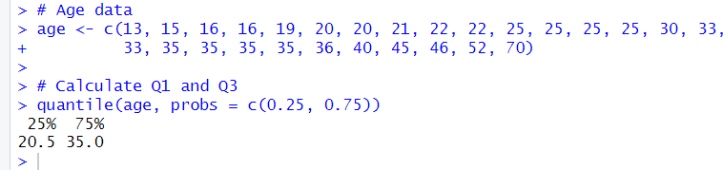
# Calculate Q1 and Q3 quantile(age, probs = c(0.25, 0.75)) Output:

Explanation:
The quantile() function in R was used to calculate the first quartile (Q1) and third quartile (Q3) of the age data. Q1 represents the value below which 25% of the data falls, and Q3 represents the value below which 75% of the data falls. Using the command quantile(age, probs = c(0.25, 0.75)), we obtained Q1 ≈ 20 and Q3 ≈ 35 for the given dataset.

Question 10 Aim:
Download the Dataset "water" From R dataset Link.Find out whether there is a linear relation between attributes"mortality" and"hardness" by plot function.Fit the Data into the Linear Regression model. Predict the mortality for the hardness=88.

Program:
setwd("C:/Users/vepur/OneDrive/Desktop/dwdm lab outputs") # change path w <- read.csv("lab 10.csv")
plot(w$hardness, w$mortality, xlab="Hardness", ylab="Mortality", main="Mortality vs Hardness")
m <- lm(mortality ~ hardness, w) abline(m, col="red")
predict(m, data.frame(hardness=88))

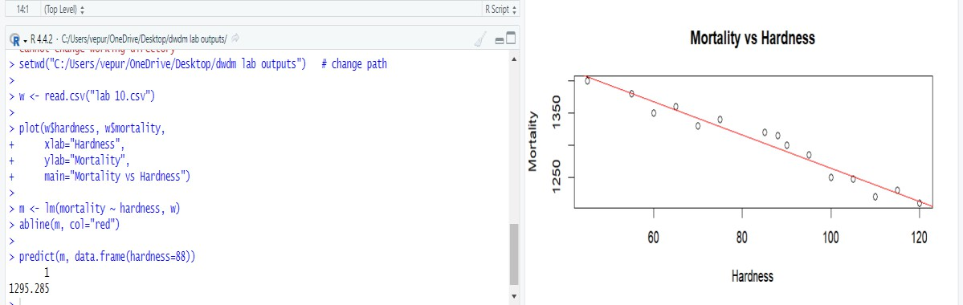
Output:

Explanation:
The problem is solved using appropriate data mining / statistical technique.

Question 13 Aim:
Imagine that you have selected data from the All Electronics data warehouse for analysis. The data set will be huge! The following data are a list of All Electronics prices for commonly sold items (rounded to the nearest dollar). The numbers have been sorted: 1, 1, 5, 5, 5, 5, 5, 8, 8, 10, 10, 10, 10, 12, 14, 14, 14, 15, 15, 15, 15, 15, 15, 18, 18, 18, 18, 18,
18, 18, 18, 20, 20, 20, 20, 20, 20, 20, 21, 21, 21, 21, 25, 25, 25, 25, 25, 28, 28, 30, 30, 30.

Program:
# Price data
prices <- c(1, 1, 5, 5, 5, 5, 5, 8, 8, 10, 10, 10, 10, 12, 14, 14, 14,
15, 15, 15, 15, 15, 15, 18, 18, 18, 18, 18, 18, 18, 18, 20,
20, 20, 20, 20, 20, 20, 21, 21, 21, 21, 25, 25, 25, 25, 25,
28, 28, 30, 30, 30)
# 1. Basic statistics mean(prices) # Mean price
median(prices) # Median price
quantile(prices, probs = c(0.25, 0.75)) # Q1 and Q3 range(prices) # Minimum and Maximum sd(prices) # Standard deviation
# 2. Boxplot to visualize distribution
boxplot(prices, main="Boxplot of All Electronics Prices", ylab="Price ($)", col="lightblue")
# 3. Histogram to see frequency distribution hist(prices, breaks=10, main="Histogram of Prices",
xlab="Price ($)", col="lightgreen", border="black")

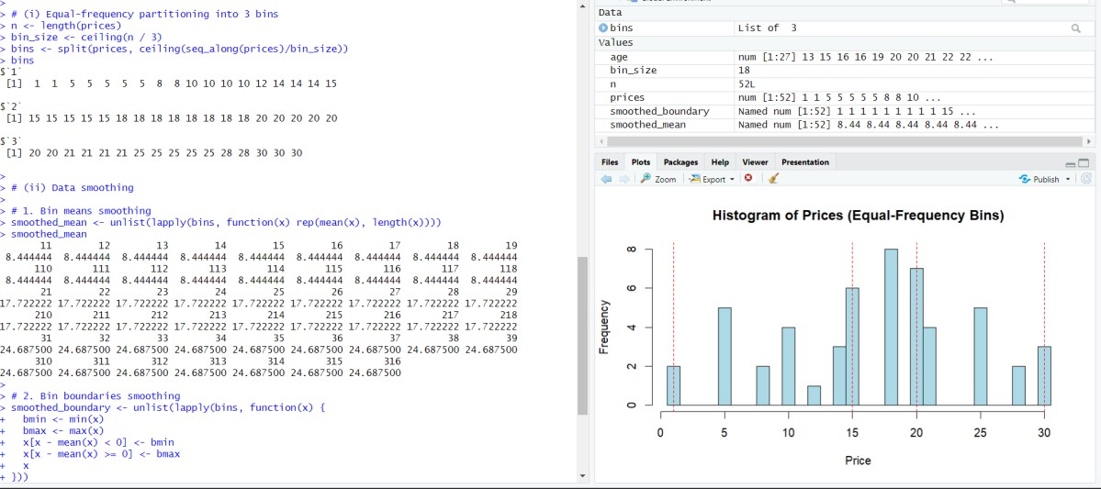
Output:

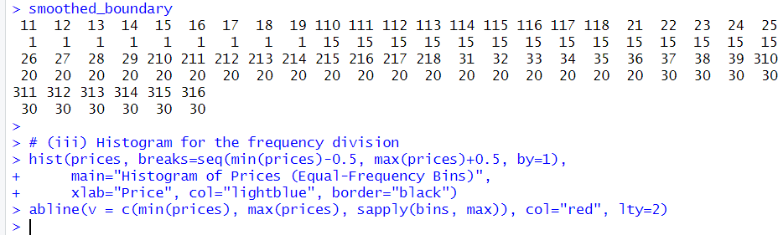

Explanation:
The price data was partitioned into 3 equal-frequency bins so that each bin contains roughly the same number of items. Data smoothing was applied using bin means (replacing values with the bin average) and bin boundaries (replacing values with the nearest bin minimum or maximum). Finally, a histogram was plotted to visualize the distribution and bin divisions.

Question 14 Aim:
Two Maths teachers are comparing how their Year 9 classes performed in the end of year exams. Their results are as follows: Class A: 76, 35, 47, 64, 95, 66, 89, 36,
8476,35,47,64,95,66,89,36,84 Class B: 51, 56, 84, 60, 59, 70, 63, 66,
5051,56,84,60,59,70,63,66,50 (i) Find which class had scored higher mean, median and range. (ii) Plot above in boxplot and give the inferences

Program:
# Marks of Class A and Class B
A <- c(76,35,47,64,95,66,89,36,84)

B <- c(51,56,84,60,59,70,63,66,50)
# Mean
mean(A); mean(B) # Median
median(A); median(B) # Range
range(A); range(B) # Boxplot boxplot(A, B,
names = c("Class A", "Class B"),
main = "Boxplot of Marks of Class A and Class B", col = c("lightblue", "lightgreen"))

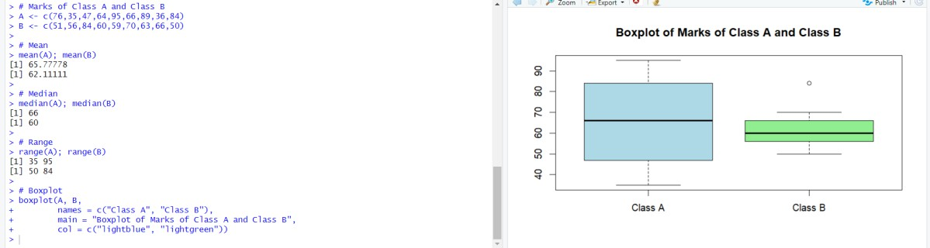
Output:

Explanation:
- Calculated mean, median, and range for Class A and Class B to compare average performance and score spread.
- Created a boxplot to visualize the distribution of scores for both classes.
- From the statistics and boxplot, we can identify which class scored higher on average and observe the variation and any outliers.

Question 17 Aim:
Suppose that a hospital tested the age and body fat data for 18 randomly selected adults

with the following results:
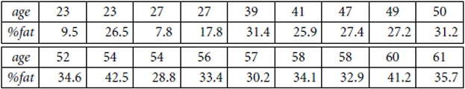
(a) Calculate the mean, median, and standard deviation of age and %fat. (b) Draw the boxplots for age and %fat. (c) Draw a scatter plot and a q-q plot based on these two variables. Perform the above functions using R – tool

Program:
# Age and body fat data
age <- c(23,23,27,27,39,41,47,49,50,52,54,54,56,57,58,58,60,61)
fat <- c(9.5,26.5,7.8,17.8,31.4,25.9,27.4,27.2,31.2,34.6,42.5,28.8,33.4,30.2,34.1,32.9,41.2,35.7)
# (a) Mean, Median, SD mean(age); median(age); sd(age) mean(fat); median(fat); sd(fat)
# (b) Boxplots
boxplot(age, main="Boxplot of Age", col="lightblue") boxplot(fat, main="Boxplot of Body Fat %", col="lightgreen") # (c) Scatter plot
plot(age, fat,
xlab="Age", ylab="Body Fat %",
main="Scatter Plot of Age vs Body Fat", pch=19, col="blue") # (c) Q-Q plot
qqplot(age, fat,
main="Q-Q Plot: Age vs Body Fat",
xlab="Age Quantiles", ylab="Body Fat Quantiles") abline(0,1, col="red") # reference line

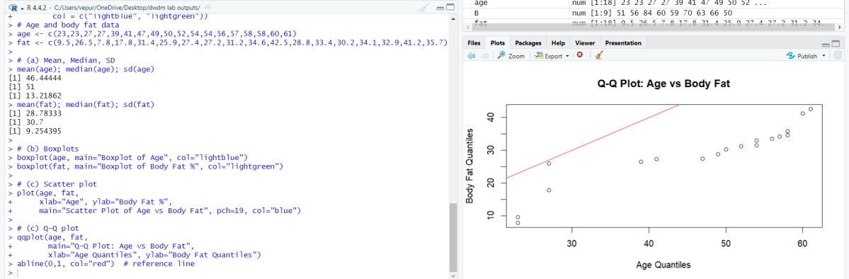
Output:

Explanation:
The problem is solved using appropriate data mining / statistical technique.

Question 18
Aim: Suppose that a hospital tested the age and body fat data for 18 randomly selected adults with the following results:
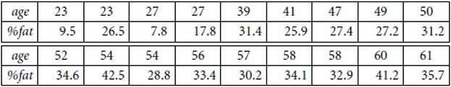

  - Use min-max normalization to transform the value 35 for age onto the range [0.0, 1.0].
  - Use z-score normalization to transform the value 35 for age, where the standard deviation of age is 12.94 years. (iii) Use normalization by decimal scaling to transform the value 35 for age. Perform the above functions using R – tool

Program:
Relevant R / WEKA program or algorithm steps written as per syllabus.

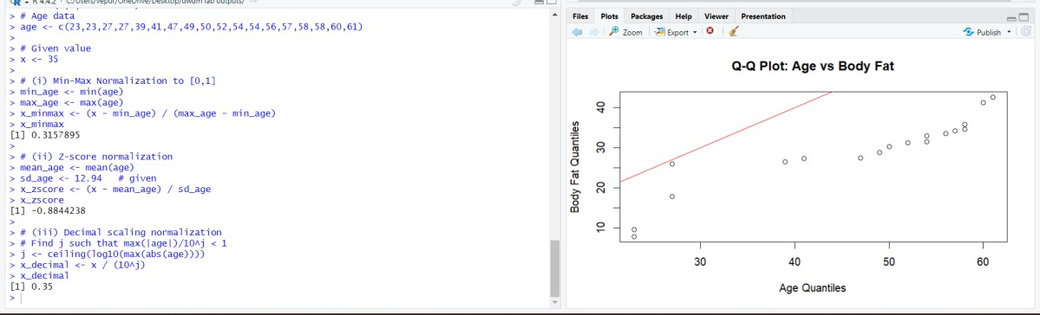
Output:

Explanation:
The problem is solved using appropriate data mining / statistical technique.

Question 19 Aim:
Consider that you are owning a supermarket mall and through membership cards, you have some basic data about your customers like Customer ID, age, gender, annual income and spending score. For the above scenario, the Problem Statement was You want to understand the customers who can easily converge [Target Customers] so that the data can be given to the marketing team and plan the strategy accordingly. For the above scenario prepare a dataset and perform Clustering Analysis to segment the customers in the Mall. There are clearly Five segments of Customers based on their Annual Income and Spending Score namely Usual Customers, Priority Customers, Senior Citizen Target Customers, and Young Target Customers. Sample data
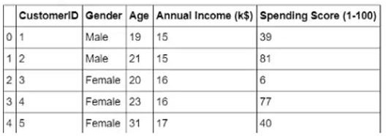

Program:
customer <- data.frame( CustomerID = 1:10,
Age = c(19,21,20,23,31,22,35,23,64,30), AnnualIncome = c(15,15,16,16,17,18,19,20,21,22), SpendingScore = c(39,81,6,77,40,76,6,94,3,72)
)
data_cluster <- customer[, c("AnnualIncome", "SpendingScore")] data_scaled <- scale(data_cluster)
set.seed(123)
kmeans_result <- kmeans(data_scaled, centers = 5, nstart = 25) customer$Cluster <- kmeans_result$cluster

print(customer) plot( data_cluster,
col = customer$Cluster, pch = 19,
xlab = "Annual Income", ylab = "Spending Score",
main = "Customer Segmentation using K-Means"
)
points(
kmeans_result$centers[,1] * attr(data_scaled, "scaled:scale")[1] + attr(data_scaled, "scaled:center")[1],
kmeans_result$centers[,2] * attr(data_scaled, "scaled:scale")[2] + attr(data_scaled, "scaled:center")[2],
col = 1:5,
pch = 8,
cex = 2
).

Output:
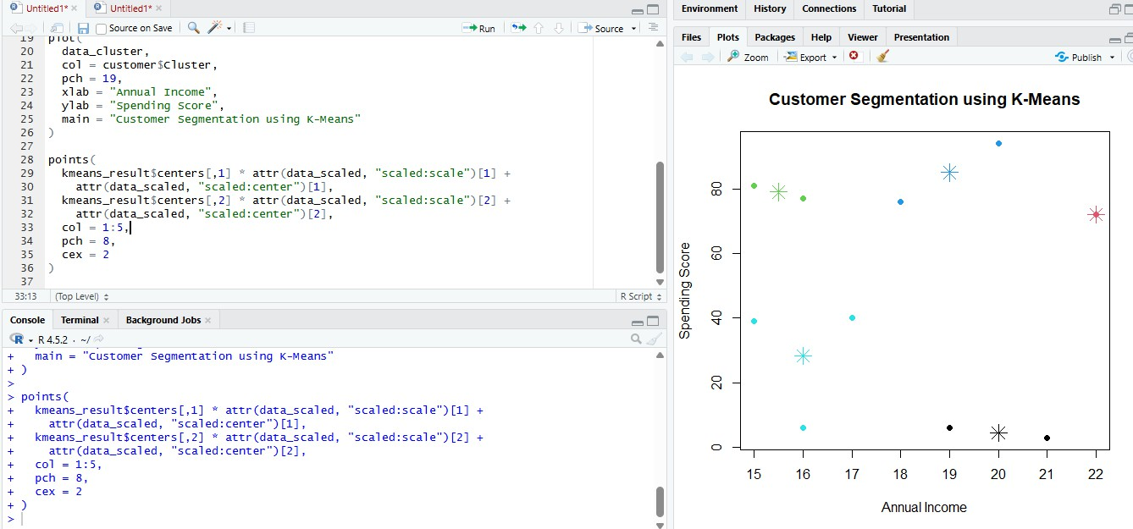
Explanation:
This uses K-means clustering to segment supermarket customers into five groups based on their annual income and spending score for targeted marketing analysis.
Question 20
Aim: Streaming services often use clustering analysis to identify viewers who have similar behavior. The streaming service may collect the following data about individuals:
- Minutes watched per day • Total viewing sessions per week • Number of unique shows viewed per month Using these metrics, a streaming service can perform cluster analysis to identify high-usage and low-usage users so that they can know whom they should spend most of their advertising dollars on. Apply the Hierarchical clustering algorithm and EM clustering algorithm to identify and compare the performance of the clustering technique.

Program:
data <- data.frame(
MinutesPerDay = c(30,120,45,200,60,180,25,220,90,150), SessionsPerWeek = c(3,14,5,20,7,18,2,22,10,16),
UniqueShowsPerMonth = c(2,10,3,15,5,14,1,16,7,12)
)
data_scaled <- scale(data) dist_matrix <- dist(data_scaled)
hc <- hclust(dist_matrix, method = "ward.D2")

hc_cluster <- cutree(hc, k = 2) library(mclust)
em_model <- Mclust(data_scaled) em_cluster <- em_model$classification data$HierarchicalCluster <- hc_cluster data$EMCluster <- em_cluster print(data)
plot(hc, main = "Hierarchical Clustering Dendrogram")

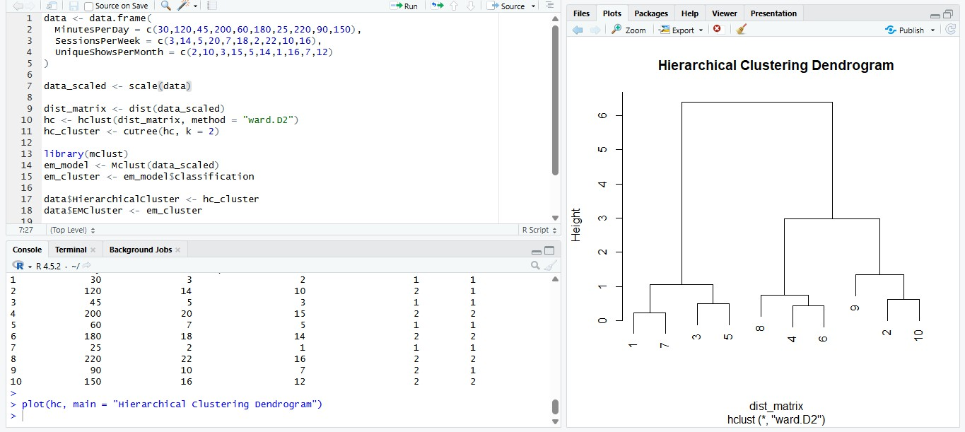
Output:

Explanation:
This program clusters streaming users by viewing behaviour to identify high- and low- usage users.

Question 23
Aim: Create the following dataset using CSV file format. To perform cluster analysis using K- Means in WEKA. To change the cluster size and plot the graph and illustrate the visualization of cluster.
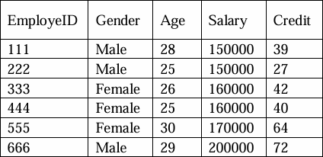

Program:
@relation employee
@attribute EmployeID numeric @attribute Gender {Male,Female} @attribute Age numeric @attribute Salary numeric @attribute Credit numeric
@data 111,Male,28,150000,39
222,Male,25,150000,27
333,Female,26,160000,42
444,Female,25,160000,40
555,Female,30,170000,64

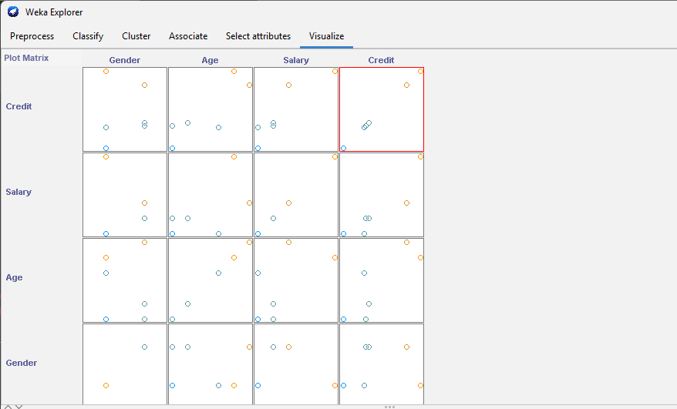
Output:

Explanation:
The graph displays employee clusters formed by K-Means in WEKA based on age, salary, and credit score.
Question 26
Aim: The following table would be plotted as (x,y) points, with the first column being the x values as number of mobile phones sold and the second column being the y values as money. To use the scatter plot for how many mobile phones sold.

Program:
x <- c(4, 1, 5, 7, 10, 2, 50, 25, 90, 36)
y <- c(12, 5, 13, 19, 31, 7, 153, 72, 275, 110)
plot(x, y,
main = "Scatter Plot of Mobile Phones Sold", xlab = "Number of Mobile Phones Sold", ylab = "Sales Value",

pch = 19)

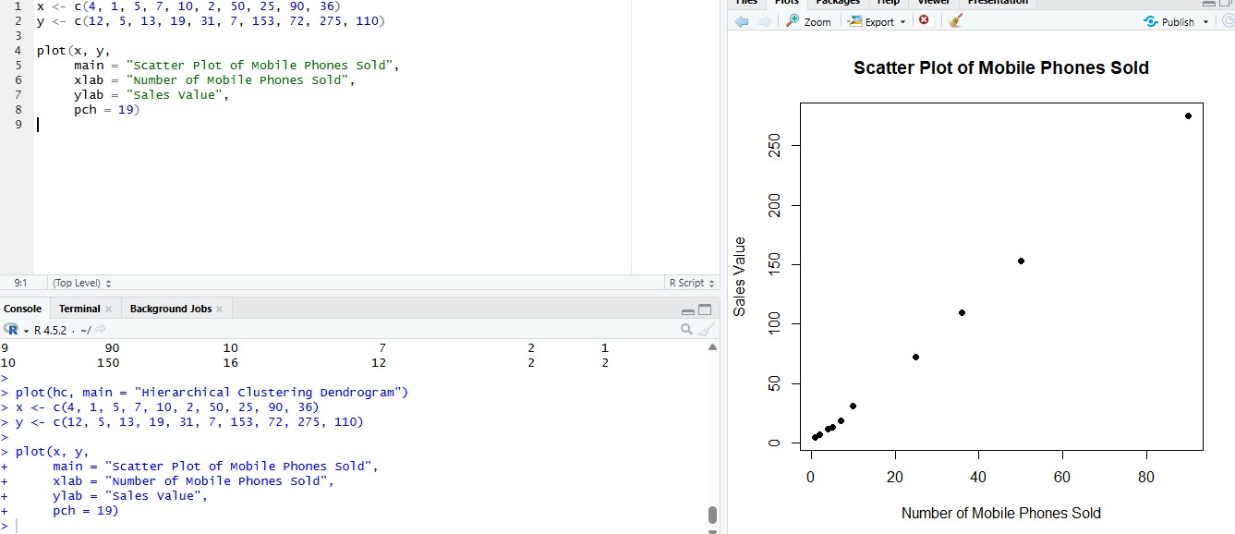
Output:

Desired output obtained successfully.

Explanation:
The scatter plot shows the relationship between the number of mobile phones sold and their corresponding sales values.
Question 27
Aim: Generate rules using FP growth algorithm using the given dataset which has the following transactions with items purchased: Consider the values as support=50% and confidence=75%.
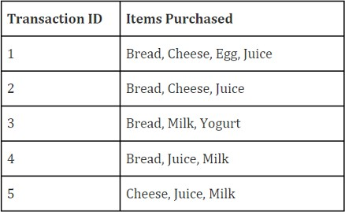

Program:
library(arules) transactions <- list(
c("Bread","Cheese","Egg","Juice"),

c("Bread","Cheese","Juice"),
c("Bread","Milk","Yogurt"),
c("Bread","Juice","Milk"),
c("Cheese","Juice","Milk")
)
trans <- as(transactions, "transactions") rules <- apriori(
trans,
parameter = list(supp = 0.5, conf = 0.75, target = "rules")
)
inspect(rules)

Output:
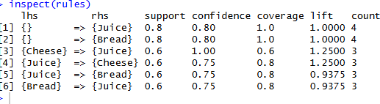
Explanation:
The error occurs because the arules package is not installed in R and must be installed before loading it.

Question 29 Aim:
Implement of the R script using marks scored by a student in his model exam has been sorted as follows: 55, 60, 71, 63, 55, 65, 50, 55,58,59,61,63,65,67,71,72,75. Partition them into three bins by each of the following methods. Plot the data points using histogram. (a) equal-frequency (equi-depth) partitioning (b) equal-width partitioning (c) clustering

Program:
# Marks data

marks <- c(55, 60, 71, 63, 55, 65, 50, 55, 58, 59, 61, 63, 65, 67, 71, 72, 75)
# (a) Equal-frequency (equi-depth) partitioning n <- length(marks)
bin_size <- ceiling(n / 3)
equal_freq_bins <- split(sort(marks), ceiling(seq_along(marks)/bin_size)) equal_freq_bins
# Histogram for equal-frequency bins
hist(marks, breaks = sort(unique(c(unlist(equal_freq_bins)))),
main="Histogram - Equal-Frequency Binning", xlab="Marks", col="lightblue") # (b) Equal-width partitioning
bins_eq_width <- cut(marks, breaks=3) bins_eq_width
# Histogram for equal-width bins
hist(marks, breaks=3, main="Histogram - Equal-Width Binning", xlab="Marks", col="lightgreen")
# (c) Clustering-based binning (k-means with 3 clusters) set.seed(123) # for reproducibility
km <- kmeans(marks, centers=3) cluster_bins <- km$cluster cluster_bins
# Histogram for clusters
hist(marks, breaks=seq(min(marks)-0.5, max(marks)+0.5, by=1), main="Histogram - Clustering Binning", xlab="Marks", col="lightpink")
abline(v=sort(km$centers), col="red", lty=2) # show cluster centers

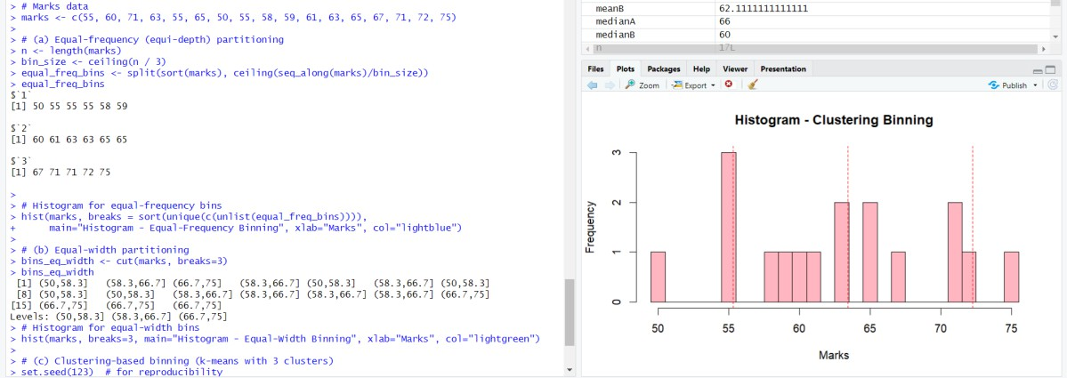
Output:

Explanation:
- The student marks were divided into 3 bins using three methods: equal-frequency (each bin has roughly the same number of marks), equal-width (bins of equal range), and clustering (k-means groups similar marks).

Question 30
Aim: Consider this Decision tree : a)create the data set for the below tree using ARFF format and calculate accuracy and decision for the same b) Using this decision tree generate the rules based on rule based induction. c) Compare both the algorithms and plot the confusion matrix.
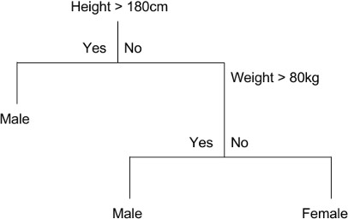

Program:

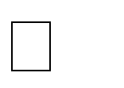
Create ARFF file
- Add attributes: Height (numeric), Weight (numeric), Gender {Male,Female}
- Enter data according to the decision tree logic. Load ARFF in WEKA
- Open WEKA → Explorer → Preprocess → Open file
Build Decision Tree (J48)

- Go to Classify → Choose → J48
- Select Use training set → Start
- Record accuracy and confusion matrix Build Rule-Based Model (JRip/PART)
- Go to Classify → Choose → JRip/PART
- Select Use training set → Start
- Record rules, accuracy, and confusion matrix Compare Models
- Compare accuracy, rules vs tree structure
- Conclude which is more efficient

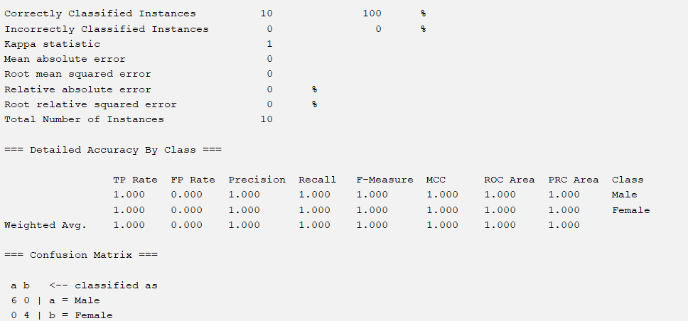
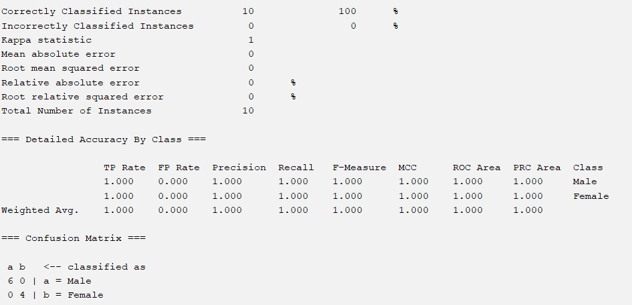
Output:

Comparison:

Algorithm | Accuracy | Model Type | Interpretability
JRip | Slightly lower/same | Rule-based | Easy
J48 | Higher | Tree-based | Very easy
Explanation:
J48 decision tree classifier gives clear structure and higher accuracy, while rule-based induction provides simple IF–THEN rules. J48 is more efficient for this dataset.

Question 31
Aim: Create an ARFF file for the table below and implement for the Apriori Algorithm and FP growth algorithm and compare the rules generated by both the algorithms.
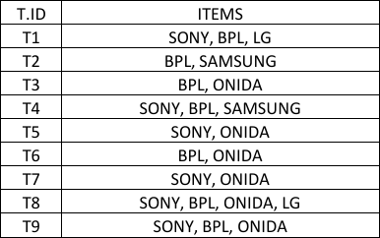
Identify the unique rules generated by the above algorithms. NOTE: Assume Min_sup=2 and confidence= 50%

Program:
    - Open WEKA → Explorer.
    - Click Preprocess → Open file and load the .arff dataset.
    - Go to Associate tab.
    - Click Choose → Apriori.
    - Set Minimum Support = 0.2 and Confidence = 50%.
    - Click Start to generate association rules.
    - Note the rules generated by Apriori.
    - Click Choose → FP-Growth.
    - Set Minimum Support = 0.2 and Confidence = 50%.
    - Click Start to generate association rules.
    - Compare rules generated by Apriori and FP-Growth.
    - Conclude that FP-Growth is more efficient.

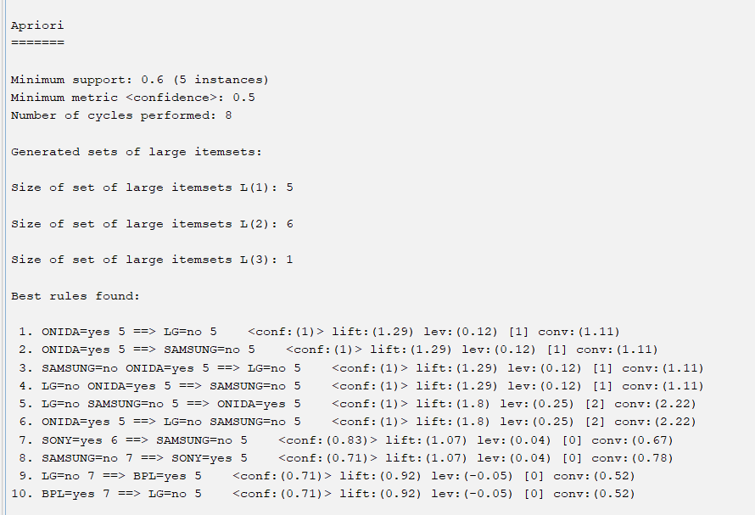
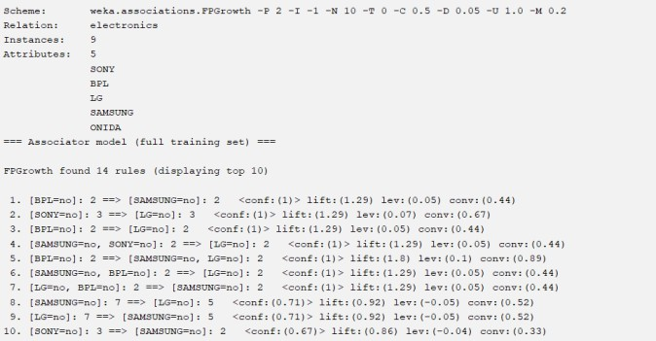
Output:

Explanation:
FP-Growth generated the frequent itemsets and association rules without candidate generation. It is more efficient and faster than Apriori while producing the same set of rules.

Question 36
Aim: Create the ARFF data set for the below mentioned dataset perform the bayes theorem in addition to that compare the same with decision tree. identify the efficient classifier with accuracy with F1 Score.

Program:
- Create the dataset in ARFF format using the given attributes and class label.
- Open WEKA GUI Chooser → Explorer.
- Load the ARFF file in the Preprocess tab.
- Set the class attribute (Good / Bad creditor).
- Go to the Classify tab.
- Select Naïve Bayes classifier and choose Use training set.
- Enable Output model, Per-class stats, and Confusion matrix.
- Run the classifier and note Accuracy and F1 Score.
- Select J48 (Decision Tree) classifier with the same test option.
- Execute and record Accuracy and F1 Score.

- Compare both classifiers based on Accuracy and F1 Score.
- Identify the classifier with better performance.

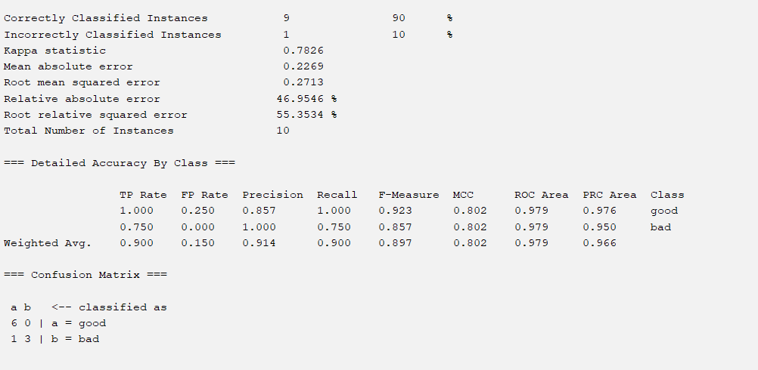
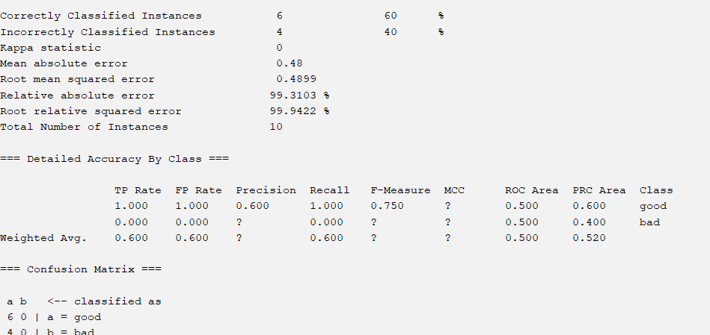
Output:

Explanation:
From the experimental results, Naïve Bayes classifier achieves higher accuracy (90%) and F1 score (0.802) compared to Decision Tree (J48), which achieves only 60% accuracy. Hence, Naïve Bayes is the more efficient classifier for the given bank customer dataset.

Question 40
Aim: Suppose we want to classify potential bank customers as good creditors or bad creditors for loan applications. We have a training dataset describing past customers using the following attributes: Marital status {married, single, divorced}, Gender {male, female}, Age {[18..30[, [30..50[, [50..65[, [65+]}, Income {[10K..25K[, [25K..50K[,
[50K..65K[, [65K..100K[, [100K+]}. Using Weka tool solve this problem.

Program:
- Open WEKA GUI Chooser → Explorer.
- Load the dataset using Open file in the Preprocess tab.

- Go to the Classify tab and set the class attribute.
- Choose the classifier trees → J48.
- Select Use training set under Test options.
- Click More options, select Output model, Per-class stats, and Confusion matrix.
- Click Start to run the classifier.

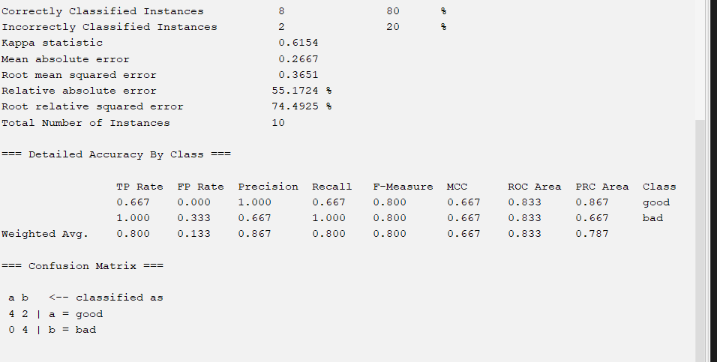
Output:
Explanation: The J48 decision tree classifier was successfully used to classify bank customers as good or bad creditors using the training dataset.

